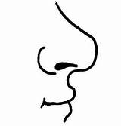  Нн  ............................................................................................................................  Н НА НИ  ...................................................................................................................  Ана нана мана  ________________________________________________________________  ________________________________________________________________  ________________________________________________________________  ________________________________________________________________ |  |  | Нн  ............................................................................................................................  Н НА НИ  ...................................................................................................................  Ана нана мана  ________________________________________________________________  ________________________________________________________________  ________________________________________________________________  ________________________________________________________________

ИМЕ И ПРЕЗИМЕ ______________________________________________________________

ИЗРАЧУНАЈ:
10 + 2 =

10 + 6 =

10 + 3 =

4+ 10 =

1 + 10 =

2 + 10 =

3 + 10 =

10 + 5 =

10 + 1 =

6+10 =

