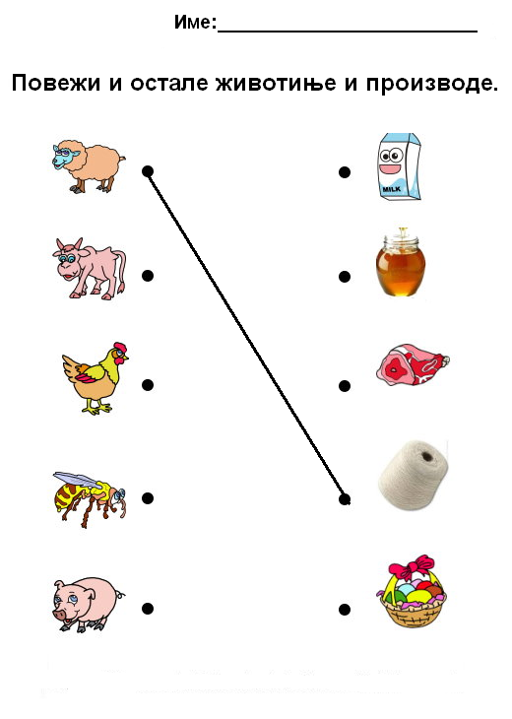

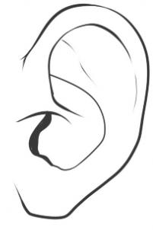
Уу

............................................................................................................................

У СУ УНА
...................................................................................................................

уста Рума ујна

________________________________________________________________

________________________________________________________________

________________________________________________________________

________________________________________________________________

ИМЕ И ПРЕЗИМЕ ______________________________________________________________

ИЗРАЧУНАЈ:
12 - 2 =

15 - 1 =

13 - 3 =

14- 2 =

16 - 5 =

12 - 1 =

13 - 0 =

15 - 4 =

16 - 2 =

11 -11 =

